 

The British College

Kathmandu

Advance Software Engineering

Name: Ravi Prakash Yadav

ID: 77298004

Table of Contents

Introduction 2

Version control 3

Interface 5

Command 6

1. circle command 6

Check valid parameter 7

Check valid command 7

Clear 8

Triangle command 9

Menu integration 10

Save 10

Open 11

About 11

Help 12

Unit test 12

Xml files 13

# Introduction

Welcome to the Shape Drawing Application, a user-friendly project created in C# using Visual Studio 2022. This Windows Form app allows you to draw circles, rectangles, and triangles by typing commands in a designated box. For circles, simply type "circle" followed by the desired radius. You can move circles to specific coordinates using the "move to x y" command. To draw rectangles, enter "rectangle l h" to set the length and height, and then use "run" to generate the shape. Triangles are created by providing parameters a, b, and c. The application integrates with Bitbucket for version control, and there are options to save, open, and exit files. Additionally, unit testing ensures code reliability and XML files organize shape configurations. Whether you're a developer or just having fun drawing shapes, this project offers an easy and creative experience. Clone the repository, open it in Visual Studio, build, and start exploring the world of interactive shape drawing!

# Version control

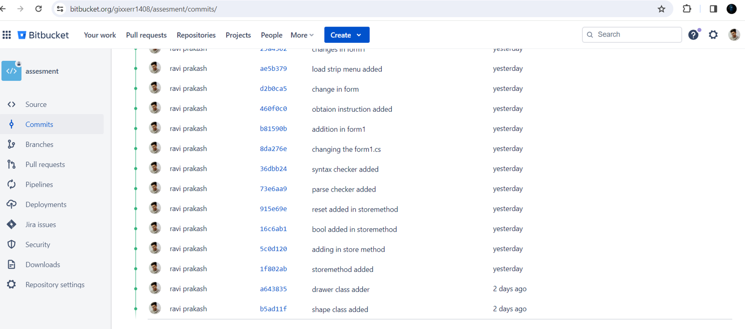

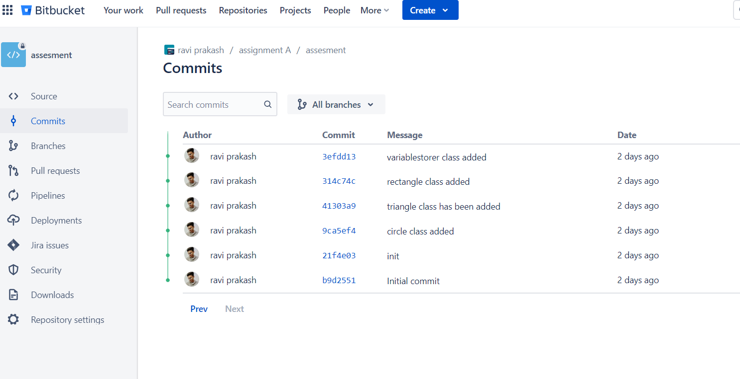

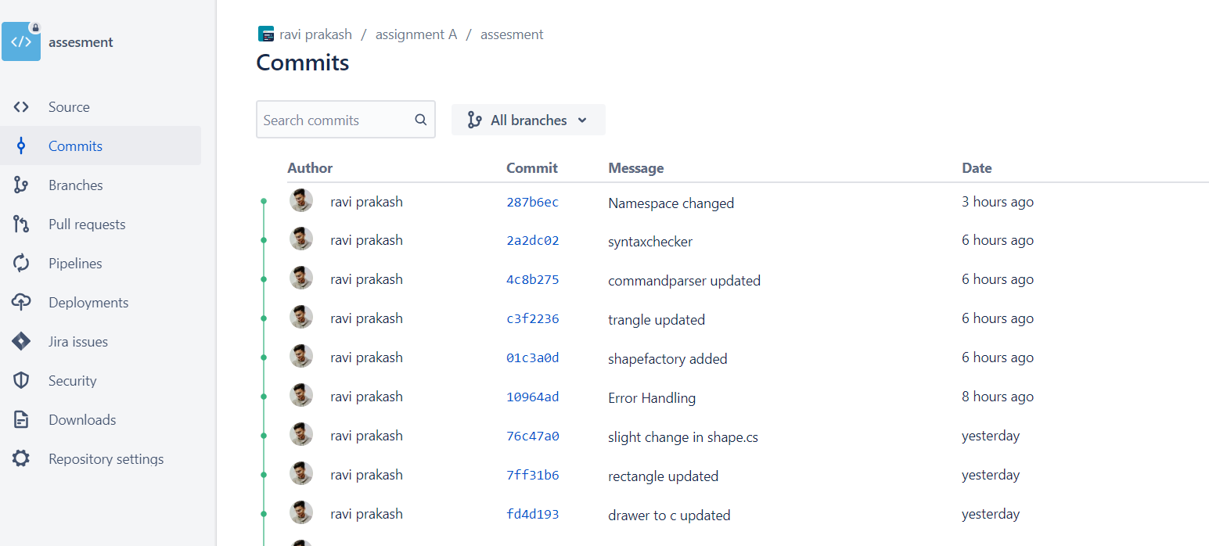

# Interface

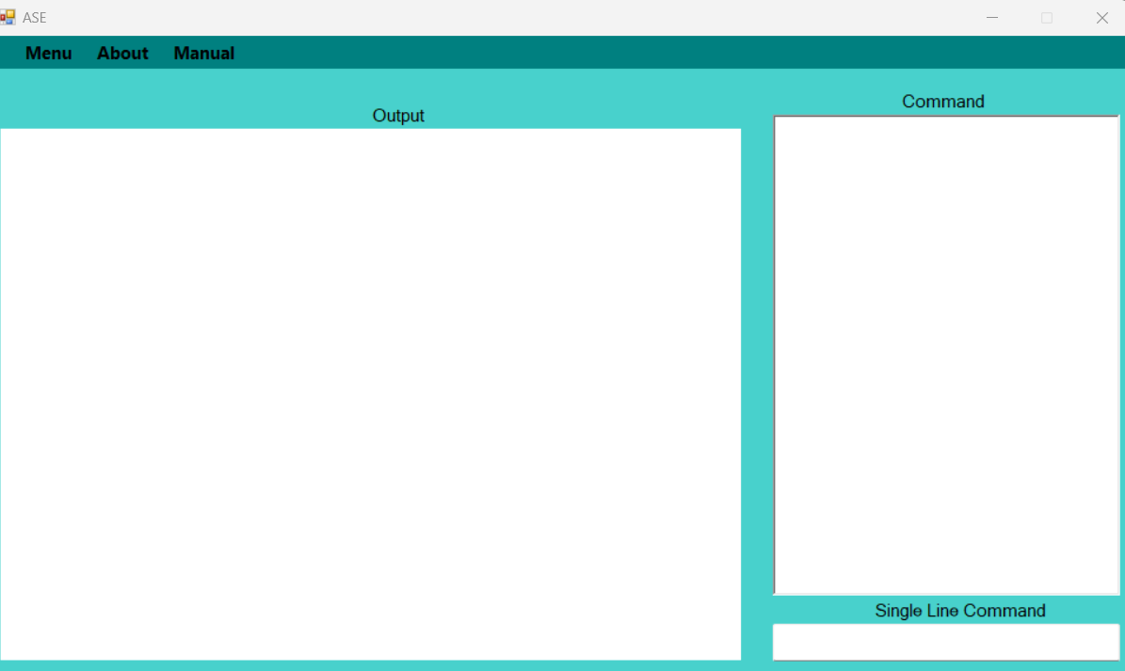

# Command

## 1. circle command

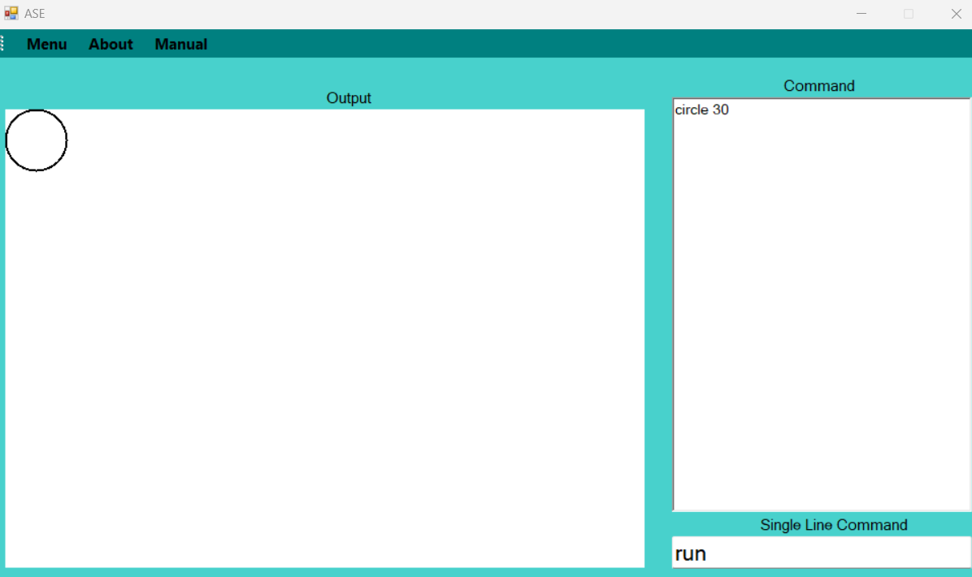

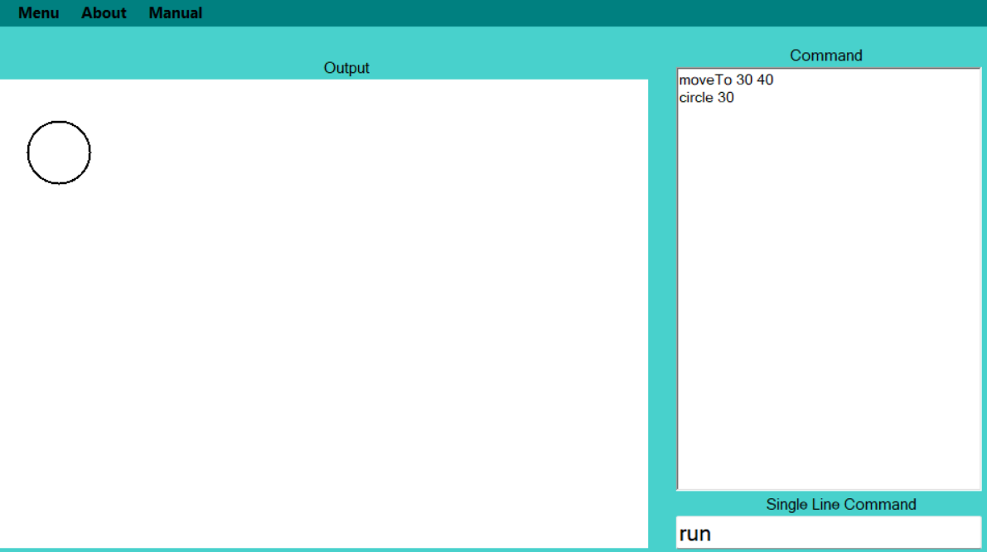

# Check valid parameter

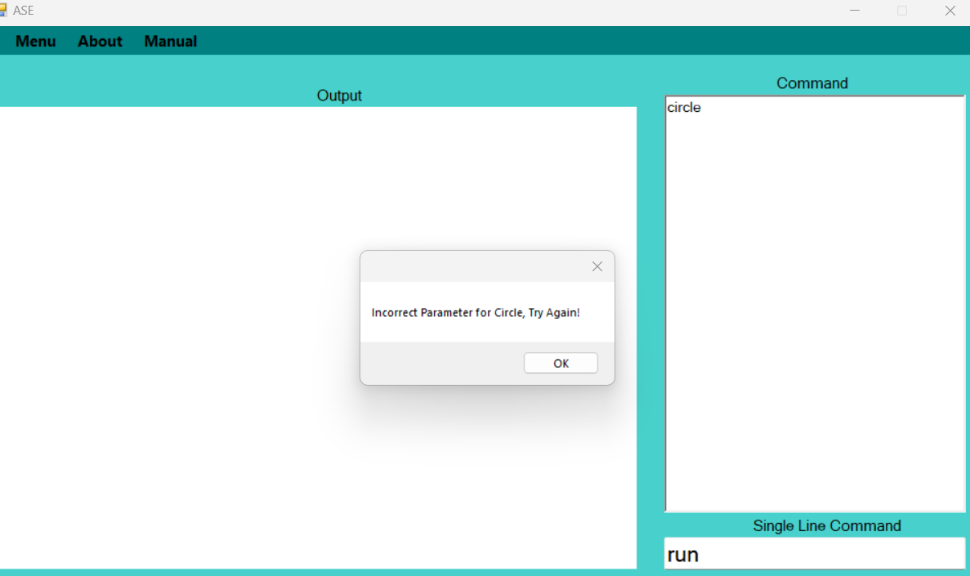

# Check valid command

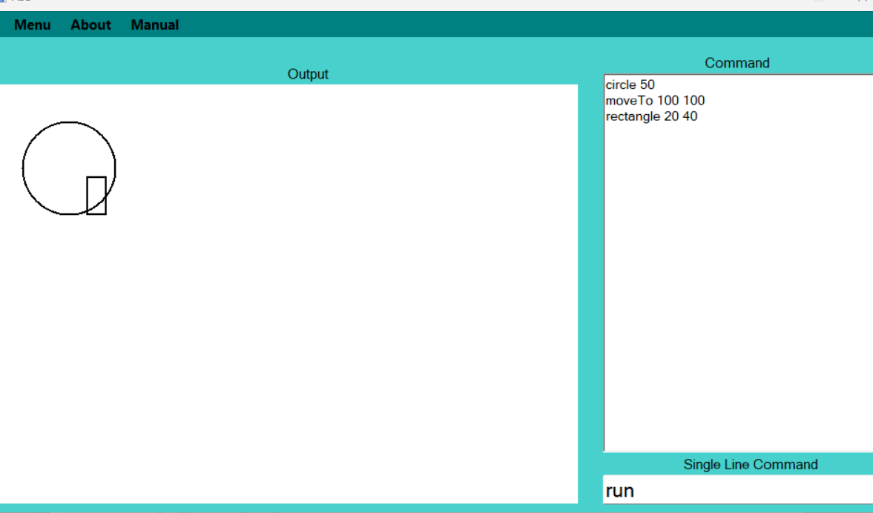

# Clear



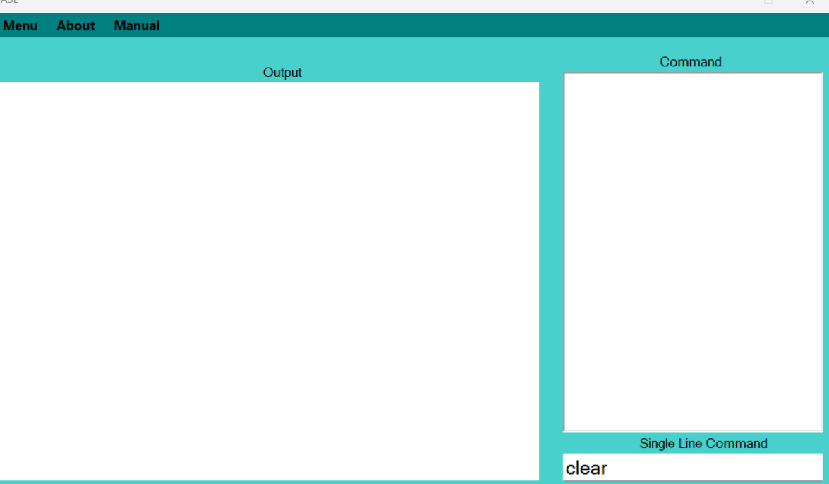

# Triangle command

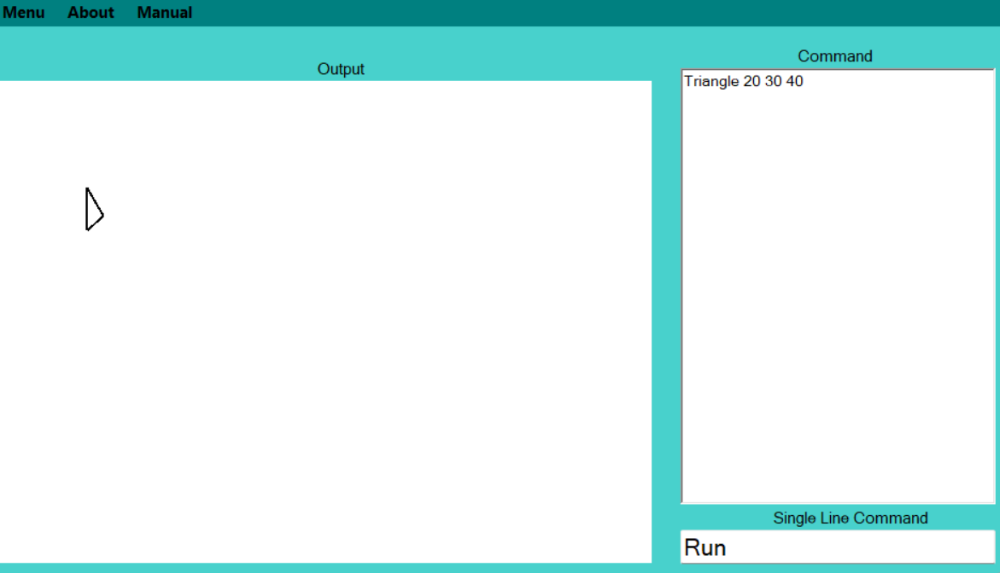

# Menu integration

# Save

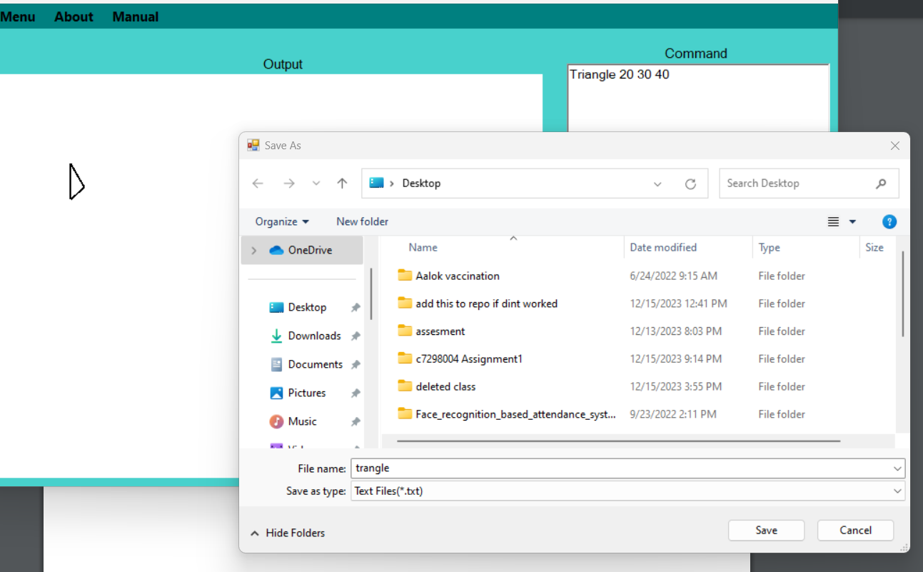

# Open

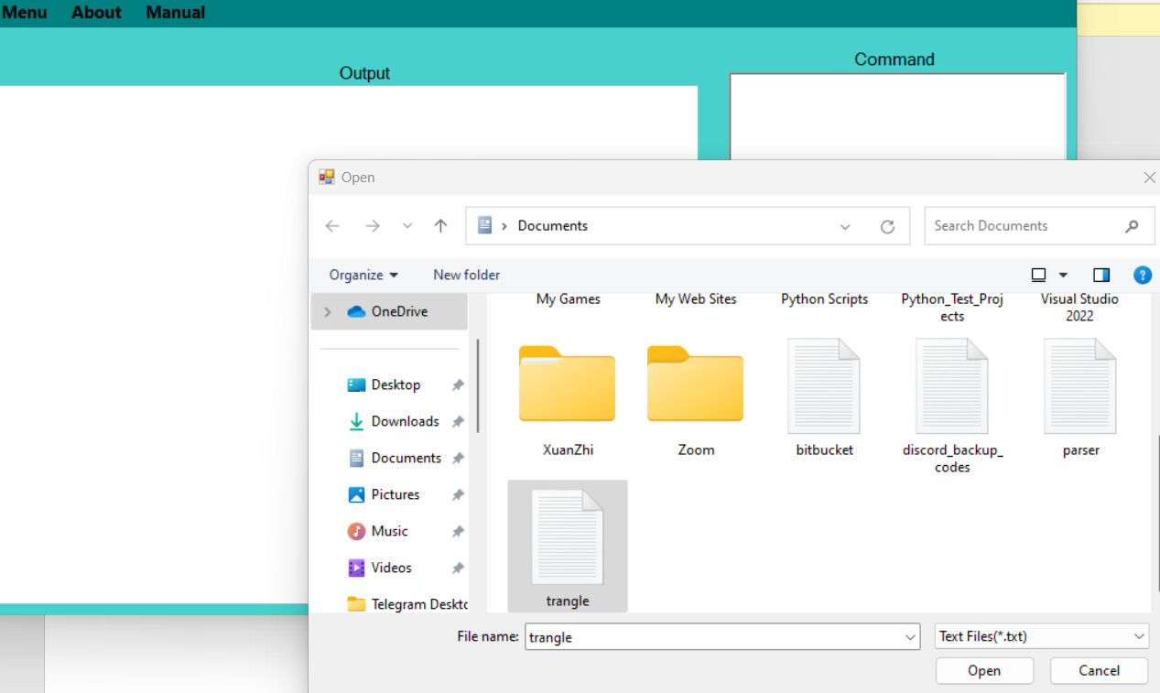

# About

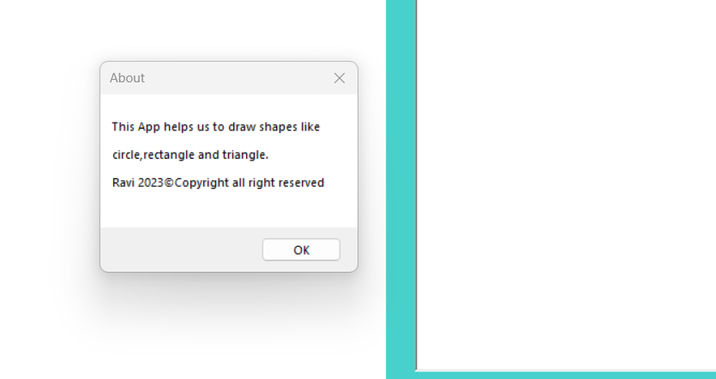

# Help

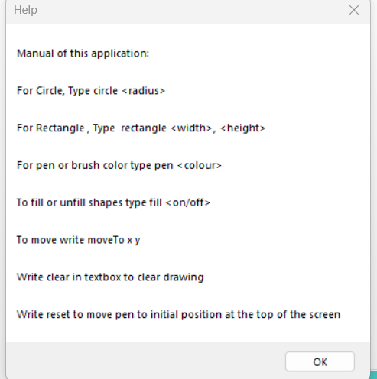

# Unit test

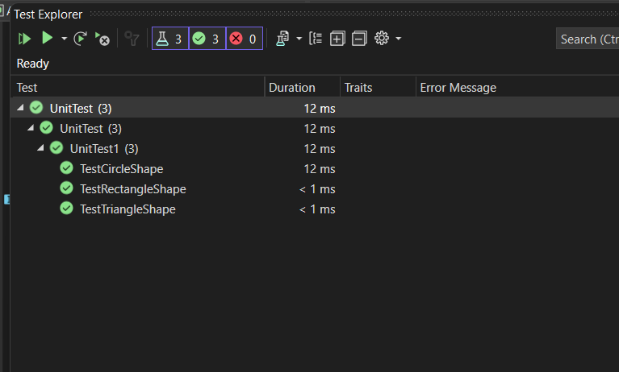

# Xml files

<?xml version="1.0"?>

<doc>

<assembly>

<name>Assignment1</name>

</assembly>

<members>

<member name="T:Assignment1.Circle">

<summary>

Created Circle class which inherits from Shape class. This class holds methods and properties for drawing circles.

</summary>

</member>

<member name="M:Assignment1.Circle.#ctor(System.Int32)">

<summary>

Constructor to initialize an instance of the class.

</summary>

<param name="r">Holds the radius of the circle</param>

</member>

<member name="M:Assignment1.Circle.Drawer(Assignment1.Drawer)">

<summary>

This method holds specific Shape (Circle) to draw or fill on Shape if Fill is on.

</summary>

<param name="myCanvas">myCanvas holds the drawing area</param>

</member>

</members>

</doc>

<?xml version="1.0"?>

<doc>

<assembly>

<name>Assignment1</name>

</assembly>

<members>

<member name="T:Assignment1.Drawer">

<summary>

This class holds methods and properties required during drawing. It includes the initial position of the pen and some useful methods.

</summary>

</member>

<member name="F:Assignment1.Drawer.g">

<summary>

Creates an instance of data graphics.

</summary>

</member>

<!-- Add other members of Drawer class here -->

</members>

</doc>

<?xml version="1.0"?>

<doc>

<assembly>

<name>Assignment1</name>

</assembly>

<members>

<member name="T:Assignment1.Form1">

<summary>

Created Form1 class which inherits from Form. This class holds methods and properties for a bitmap, slider, Menu bar, and the Enter event on the command prompt.

</summary>

</member>

<!-- Add members of Form1 class here -->

</members>

</doc>

<?xml version="1.0"?>

<doc>

<assembly>

<name>Assignment1</name>

</assembly>

<members>

<member name="M:Assignment1.Program.Main">

<summary>

The main entry point for the application.

</summary>

</member>

</members>

</doc>

<?xml version="1.0"?>

<doc>

<assembly>

<name>Assignment1</name>

</assembly>

<members>

<member name="T:Assignment1.Rectangle">

<summary>

Created Rectangle class which inherits from Shape class.

</summary>

</member>

<member name="M:Assignment1.Rectangle.#ctor(System.Int32,System.Int32)">

<summary>

Constructor to initialize an instance of the class.

</summary>

<param name="x">Assigns a value for height</param>

<param name="y">Assigns a value for width</param>

</member>

<member name="M:Assignment1.Rectangle.Drawer(Assignment1.Drawer)">

<summary>

This method holds specific Shape (Rectangle) to draw or fill on Shape if Fill is on.

</summary>

<param name="myCanvas">myCanvas holds the drawing area</param>

</member>

</members>

</doc>

<?xml version="1.0"?>

<doc>

<assembly>

<name>Assignment1</name>

</assembly>

<members>

<member name="T:Assignment1.Triangle">

<summary>

Created Triangle class which inherits from Shape class. This class is responsible for drawing triangles.

</summary>

</member>

<member name="M:Assignment1.Triangle.#ctor(System.Int32,System.Int32,System.Int32)">

<summary>

Constructor to initialize an instance of the class.

</summary>

<param name="x">Holds hypotenuse value provided by the user</param>

<param name="y">Holds base value provided by the user</param>

<param name="z">Holds adjacent value provided by the user</param>

</member>

<member name="M:Assignment1.Triangle.Drawer(Assignment1.Drawer)">

<summary>

This method holds specific Shape (Triangle) to draw or fill on Shape if Fill is on.

</summary>

<param name="myCanvas">myCanvas holds the drawing area</param>

</member>

</members>

</doc>